GOVERNMENT OF RECONCILIATION AND NATIONAL UNITY

MINISTRY OF THE ENVIRONMENT AND
NATURAL RESOURCES (MARENA)

FINAL EVALUATION REPORT

PROGRAM OF REDUCTION OF RISKS AND VULNERABILITY TO FLOODS AND DROUGHTS IN THE ESTERO REAL RIVER BASIN

Managua, December 2015
Content
I. INTRODUCTION 4
1.1. OBJECTIVES OF THE FINAL EVALUATION 6
1.2. CRITERIA AND QUALIFICATIONS FOR THE EVALUATION 7
II. PROGRAM DESCRIPTION 7
2.1 BACKGROUND. 7
2.2. DEVELOPMENT GOALS AND IMMEDIATE OBJECTIVES OF THE PROGRAM 9
2.2.1. The program components to achieve the results were: 10
2.2.2. Baseline Indicators 11
III. EVALUATION OF THE PROGRAM RESULTS. 12
3.1 Relevance. 12
3.2. EFFECTIVENESS 13
3.2.1 EFFECTIVENESS ACHIEVED FOR EACH OF THE PROGRAM EXPECTED RESULTS. 14
3.3. EFFICIENCY. 32
3.3.1 The role of the Model of Alliances to achieve greater efficiency 33
3.3.2 Overall rating of the program in terms of relevance, effectiveness and efficiency 35
3.4. SUSTAINABILITY. 35
3.4.1 Financial and economic dimension. 35
3.4.2 Socio-environmental and political dimension. 36
3.4.3 Institutional framework and governance. 37
3.4.4 Environmental Dimension. 38
3.4.6. Overall rates. 39
IV. EVALUATION OF THE PROCESSES THAT CONTRIBUTED TO ACHIEVE THE PROGRAM RESULTS. 39
4.1 Lessons from other projects used for the program design and implementation. 39
4.2. The role of local communities in the program. 40
4.3. Inclusion of Youth and Women through gender practices. 41
4.4. Financial controls and audits 44
4.5. Program Management Arrangements 45
V. PROGRAM CONTRIBUTION TO THE OBJECTIVES, GOALS AND IMPACTS OF THE ADAPTATION FUND (AF) 45
VI. ASSESSMENT OF THE MONITORING AND EVALUATION SYSTEM 48
6.1 Evaluation of the Program M&E Plan 48
6.2 Program baseline 50
VII. LESSONS LEARNED AND ANALYSIS FOR SUSTAINABILITY. 50
7.1 Lessons learned 50
7.1.1 Uncertainty around Climate Change Impacts. 51
VIII. CONCLUSIONS AND RECOMMENDATIONS 55
8.1. Conclusions. 55
8.2 Recommendations 55
8.3 Description of Annexes 56
IX. BIBLIOGRAPHY 59
ANNEXES 60

INTRODUCTION
The Government of National Reconciliation and Unity under the leadership of Comandante Daniel Ortega is implementing the National Human Development Plan (PNDH) and the National Strategy for the Environment and Climate Change (ENACC) to improve the living condition of the Nicaraguan, especially the poorest, within a national context of macro-economic stability and social cohesion. This strategy is based on 12 guidelines, of which the Nº 12 stands out addressing "The protection of Mother Earth, the adaptation to climate change and the holistic management of risks and disasters".
Climate change adaptation in Nicaragua is implemented through measures implemented jointly by the different government agencies to deal with the impacts of this phenomenon, including droughts or heavy storms causing damage and human and material losses.
In this context, the "Program of Reduction of Risks and Vulnerability to Floods and Droughts in the Estero Real River Basin" was implemented to reduce such risks caused by climate change and variability in the municipalities of El Sauce and Achuapa, in the department of Leon, and Villanueva, in the department of Chinandega. Located in a basin with an area of 1,425 square miles, this program was focused in the upper area, specifically in Rio Villanueva basin (599 sq. mi) also known as Rio Grande or Aquespalapa.
This paper presents the actions strategically implemented by this program and will feed into the final performance evaluation, as the final process of the project cycle.
The content of this report starts with the background from which the program was conceived; its political, technical and legal frameworks; the priorities of the Government of National Reconciliation established in the National Human Development Plan; and the impact of climate change in livelihoods of the inhabitants of the municipalities of El Sauce and Achuapa, in Leon, and Villanueva, in Chinandega, located in one of the largest basins of the country.
This report present an assessment of the scope and outputs initially proposed in contrast with the actual results, in terms of relevance, efficiency, effectiveness, sustainability and impact, as established on the guidelines for final evaluation of Projects/programs of the AF and the evaluation criteria contained in the Monitoring, Follow-up and Evaluation System of the Government, through the Secretariat of the Presidency and the Ministry of the Environment and Natural Resources (MARENA).
According to the general objective, aimed at reducing the risks from droughts and floods caused by climate change and variability, the document provide insights for the final performance evaluation, based on the design and expectations contained in the Logical and the Results Framework established in the official project document, which was made through an on-site participatory process during the formulation process in 2010.
The final evaluation considers the program sustainability as probable, since there are moderate risks that might affect the sustainability dimensions analyzed. This is true especially due to the climate change which is cumulative and unpredictable, causing uncertainty and generating impacts on ecosystems and populations.
The final evaluation considers the contribution of the Program to the Objectives, Goals and Impacts of the AF satisfactory.
The Final Evaluation report concludes with a list of lessons learned and a set of recommendations to be implemented in future projects of adaptation to climate change to ensure effectiveness, sustainability and efficiency.

OBJECTIVES OF THE FINAL EVALUATION

Overall, the evaluation has the following objectives:
- Promote the AF accountability and transparency through systematic evaluation and reporting about the levels of compliance of the program;
- Organize and consolidate experiences and lessons that may help improve the selection, design, implementation and evaluation of future interventions financed by the Adaptation Fund;
- Understand how the Program achievements contribute to comply with the AF mandate.
- Provide feedback to decision-making processes to improve existing or future projects, programs or policies;
- Assess the relevance, effectiveness and efficiency of the program design, objectives and performance.

According to the provisions contained in the guidelines for final evaluations of projects/programs of the Adaptation Fund, the final evaluation assesses the following dimensions:
- Attainment of the program effects, including quantitative measurements, particularly considering the achievements of the concrete adaptation measures proposed;
- Assessment of the risks for sustaining and advancing the impacts at the end of the program, including quantitative measurements.
- Evaluation of the processes that influenced the attainment of the program results, including the country's level of preparation, readiness and appropriation, the participation of protagonists, the financial management, the supervision and the support of the implementing agency as well as the progress and delays in the program implementation.
- Evaluation of the program contribution to the goals, objectives, impacts and purposes of the Adaptation Fund, including a report on the standard/main AF indicators.

CRITERIA AND QUALIFICATIONS FOR THE EVALUATION

The final performance evaluation of the program was carried out comparing the expectations contained in the Logical and Results Frameworks, which provided performance and impact indicators, along with the relevant means of verification. The evaluation includes criteria of relevance, effectiveness, efficiency, sustainability and impact. The grades should be provided considering the criteria established in the guidelines for final evaluation of projects/programs of the Adaptation Fund (See Annex 2; TABLE 3. AF Evaluation Criteria)

II. PROGRAM DESCRIPTION

2.1 BACKGROUND.

Nicaragua faces severe impacts related to extreme natural phenomena, combined with a significant climate variability, whose socio-economic impacts are magnified by the high levels of poverty. Climate variability, especially during the episodes of El Niño-Southern Oscillation (ENOS), causes droughts leading to significant losses in the agricultural sector, which provides employment to 60% of the population and is fundamental for national food security.
During the rainy season, devastating floods destroy crops, infrastructure and houses. In a predominantly sub-humid tropical climate, characterized by strong inter-annual variability, the climate change trends become a growing threat to the sustainability of development and welfare for poor rural families and communities in many regions. The current variability will be aggravated by the climate trends.
The areas mostly affected by climate change are the regions located in the called Dry Corridor, including the North and Pacific regions of Nicaragua and the municipalities located in the departments of Leon and Chinandega, where the program was implemented. Considering climate change conditions, estimations consider these regions will receive an average precipitation of 500 mm per year, which would have significant negative impact in agriculture and cattle-raising activities during the dry season; many surface water sources dry up and the insufficient precipitation limit the access to water, reducing crop yields and family income. This will happen even if there is not a total drought, which will have a negative impact on water availability and quality.

In Chinandega and Leon, the Estero Real River basin (1,425 sq. mi) and in particular the Villanueva River sub-basin (599 sq. mi) also known as Rio Grande or Aquespalapa, are an example of the combined impacts of poor development models and strong climate variability. In 2010 deforestation and inappropriate land management practices, particularly in the upper and middle basins, caused high rates of erosion and sedimentation that already undermined agricultural productivity and threatened food security. During the rainy season, landslides in the middle basin and big floods in the lower and middle basins are common, aggravated by extreme events like hurricanes or storms, causing losses in crops, human lives, cattle, and infrastructure, as well as a progressive deterioration of the family and community economy.

2.2. DEVELOPMENT GOALS AND IMMEDIATE OBJECTIVES OF THE PROGRAM

The programs was aimed to reduce the risks of droughts and floods caused by climate change and variability in the Estero Real River basin. To achieve this objective, the program made investments focused on water harvesting, long-term farm planning and capacity building for 1,005 families in 29 communities of three municipalities and National Government Institutions. The program developed an adaptation scheme as strategy to materialize the National Strategy for the Environment and Climate Change approved in 2010.

The program was implemented in eight micro-basins, vulnerable to climate change, located in the Villanueva River, in the upper basin of the Estero Real River basin. These micro-basins were selected considering their critical location in the Dry Corridor, in the municipalities of El Sauce, Achuapa and Villanueva, departments of Leon and Chinandega (Western Region of Nicaragua). As they are located in the higher basin slopes, they have the function to reduce water runoff and silting which cause floods in the middle and lower areas of the basin (See map below)

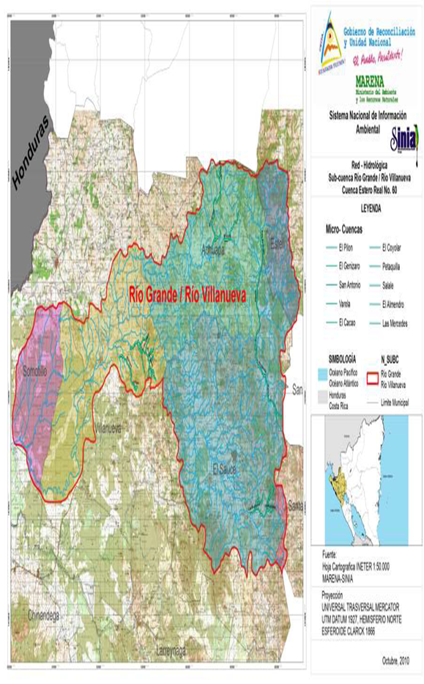

2.2.1. The program components to achieve the results were:

The program was designed with four expected components and results:

Component 1. Investment in infrastructure for retention and use of rain and superficial water in eight micro-basins located in the Estero Real River basin.

Expected result. Reduced the risk of climatically induced water shortage for homes and small scale production in eight micro-basins of the upper areas of the Estero Real River basin.

Component 2. Introduction of climatically resilient agro-ecological practices to make an effective use of available water.
Expected result. Increased the eco-systemically resilient agro-ecological practices for effective use of the available water in the eight target micro-basins.

Component 3. Training and institutional development in micro-basins, municipalities and national institutions involved.
Expected Result. Strengthened the institutional capacity for incorporating climate change risk management in work plans, policies and policy instruments affecting the Villanueva River sub-basin and the Estero Real River basin.

Component 4. Ongoing monitoring and analysis of the weather conditions, changes in land use, water flows and soil quality.
Expected Result. Disseminated the results and lessons learned about developing climate change resilience in vulnerable rural communities. This will be based on a permanent monitoring and analysis of weather conditions, changes in land use, water flows and soil quality.

2.2.2. Baseline Indicators

In the program document and the Inception Report (MARENA 2011) there is a baseline with the following indicators, which are taken up in the final evaluation:
TABLE 4. Baseline indicators.

Indicator | Baseline
Number of rural families in the selected micro-basins with at least one annual harvest. | 400
Percentage of farms in each micro-basin with access to irrigation through water facilities built with program resources. | 0
Area in hectares to expand irrigation | 67.55 ha
Water volume (liters/sec) distributed through the infrastructure of the community irrigation system. | 0 lt./sec.
Percentage of farmers in each micro-basin, whose water use is rated as satisfactory in relation to the relevant technical guidelines. | 5%
Number of water harvesting structures installed and working at micro-basin level | 0
Percentage of rural families implementing agro-ecological farm transformation plans in each micro-basin. | 5%
Number of rural families with agro-ecological farm transformation plans. | 0
Area in hectares covered by the agro-ecological farm transformation plans implemented. | 0
Percentage increase of the plant-covered areas in each micro-basin. | 25%
Forest area (in hectares) for aquifer recharging and protection of riparian zones. | 0
Number of families benefited with house and yard investments made through the agro-ecological farm transformation plans. | 0
A proposal based on the experience endorsed by three municipal governments about the functioning of a Sub-basin Committee of the Villa Nueva River. | 0
Municipalities in the basin with measures for climate change adaptation included in their official plans and relevant policies. | 0
Lessons learned in the eight micro-basins and the Villanueva River sub-basin available in SINIA (National System of Environmental Information) and other websites, and disseminated through exchange workshops. | 0
Source: List of indicators in the Program baseline, according to PRODOC.

III. EVALUATION OF THE PROGRAM RESULTS.

The evaluation of the program results aims to determine relevance and effectiveness per result, using as starting point the baseline to assess the outputs in function of the results and determine the increase in adaptation capacity, as an objective to analyze.
The program, from start to finish, produced lessons and experiences relevant to improve the responsiveness of the protagonists and increase the ecosystems adaptation to climate change through community management of basins and adaptation. These experiences can be taken up by other similar programs or projects both at national and regional levels.

3.1 RELEVANCE.
Relevance is understood as the consistency between the project objectives, the needs identified and the interests of the protagonists, inhabitants and institutions.
The results of the Program "Reduction of Risks and Vulnerability to Floods and Droughts in the Estero Real River Basin" are relevant because of its consistency with the political framework implemented by the Government of Reconciliation and National Unity through the National Human Development Plan (NHDP) and the National Strategy for the Environment and Climate Change.

Consequently, the program is consistent with the following policies of the NHDP: Conservation, Protection of water sources and water harvesting, complemented with community, municipal and basin planning; Environmental Defense and Protection of Natural Resources through the implementation of environmental restoration systems to protect aquifer recharge areas; Environmental Education; Climate Change Adaptation through environmental protection plans implemented by families to deal with this phenomenon; Conduct studies and strengthen the information systems on environment and climate change.

3.2. EFFECTIVENESS
Effectiveness determines the requirements under which the intervention objectives were or are expected to be achieved through the Program, taking into account their relative importance.
The program implementation was effective since its products were completed and the expected results were achieved in time with satisfactory quality, for which goals were defined in the project design. The midterm evaluation (MTE) assessed the effectiveness of the project as Highly Satisfactory, which has remained unaltered until the end.

The achievement of goals at the end of the program is the key pillar of success. According the goals and indicators, the program surpassed many of the goals, like the area of agro-ecological transformation and protection of riparian and aquifer recharge forests, which was larger due to the families interest to protect and manage them, even with their own resources. The significant saving of project financial resources in the construction of water works, with a flexible engineering approach, were the factors behind the project success in the two community irrigation systems constructed. According to Table 5, the achievement of goals was above 100%.

3.2.1 EFFECTIVENESS ACHIEVED FOR EACH OF THE PROGRAM EXPECTED RESULTS.

RESULT 1
Reduced the risk of climatically induced water shortage for homes and small scale production in eight micro-basins of the upper areas of the Estero Real River basin.
Baseline for this result
The highest part of the Estero Real River basin is made of micro-basins flowing into the Villanueva River. Traditionally, these micro-basins have expected two basic grain crops per year. The first is planted on time to be watered by rains from April through July. After a short dry season, the heatwave, a second planting is done, "la postrera". This is a very important crop season, since it enjoys heavier rainfalls from August through November. However, on several occasions, local rural families have experienced the total loss of both harvests. Losses occur not only when El Niño causes long droughts, but also when rains fail unexpectedly in critical moments of the crop cycle due to floods in the middle-lower areas of the basin.
A consultation process with the communities of Las Mercedes and Salale was conducted, which helped to define the construction of two community irrigation systems, including a proposed design.

Assessment of the outcomes related to this Result This component supported the construction of two community irrigation systems, 902 rainwater harvesting and collection structures and training to 1005 families in management, efficient use and maintenance of individual and community irrigation systems and water storage facilities.
TABLE 5. Summary of compliance with goals of Result 1 according to the Logical Framework
INDICATORS | BASELINE | EXPECTED OUTPUTS (GOALS) | ACTUAL OUTPUTS | COMPLIANCE AND EXPLANATION OF CHANGES
a) Percentage of farms in each micro-basin with irrigation, using the infrastructure built with program resources. | 0% | 90% (65 families in Las Mercedes and 20 families in Salale) | 130% (85 families in Las Mercedes and 32 families in Salale) | Goal Attainment: 144%  This variation is due to the interest of the protagonists to participate in the program.
b) Area (in hectares) to expand irrigation. | 67.55 ha | 161.5 ha. | 164.5 | Goal attainment: 102%  The increase in hectares is due to a higher participation of protagonists in the irrigation of crop areas using the new irrigation systems.
c) Water volume (liters/sec) distributed through the infrastructure of the community irrigation system. | 0 lt./sec. | 50 | 60 | Goal attainment: 120%  The average volume of water supplied by each system is 60 lt./sec.
d) Percentage of farms in each micro-basin whose water use is rated as satisfactory according to the relevant technical indications. | 5%* | 90% (Water use by at least 880 families was rated as satisfactory) | 92% | Goal attainment: 102%  The variation regarding the number of works (22 more than planned) is due to a higher demand by families to collect rainwater for different uses.
e) Number of water harvesting works installed and operating at micro-basin level. | 0 | 880 Water harvesting works | 902

Description of outputs associated to Result 1:
- Two works -Community Irrigation Systems- in the Salale and Las Mercedes micro-basins:
At the end of the program, 100 families use the two community irrigation systems in the eight micro-basins in Las Mercedes (68 families) and Salale (32 families) who have at least a harvest per year guaranteed; this represents 138% of the expected result at the end of the program (See map below).

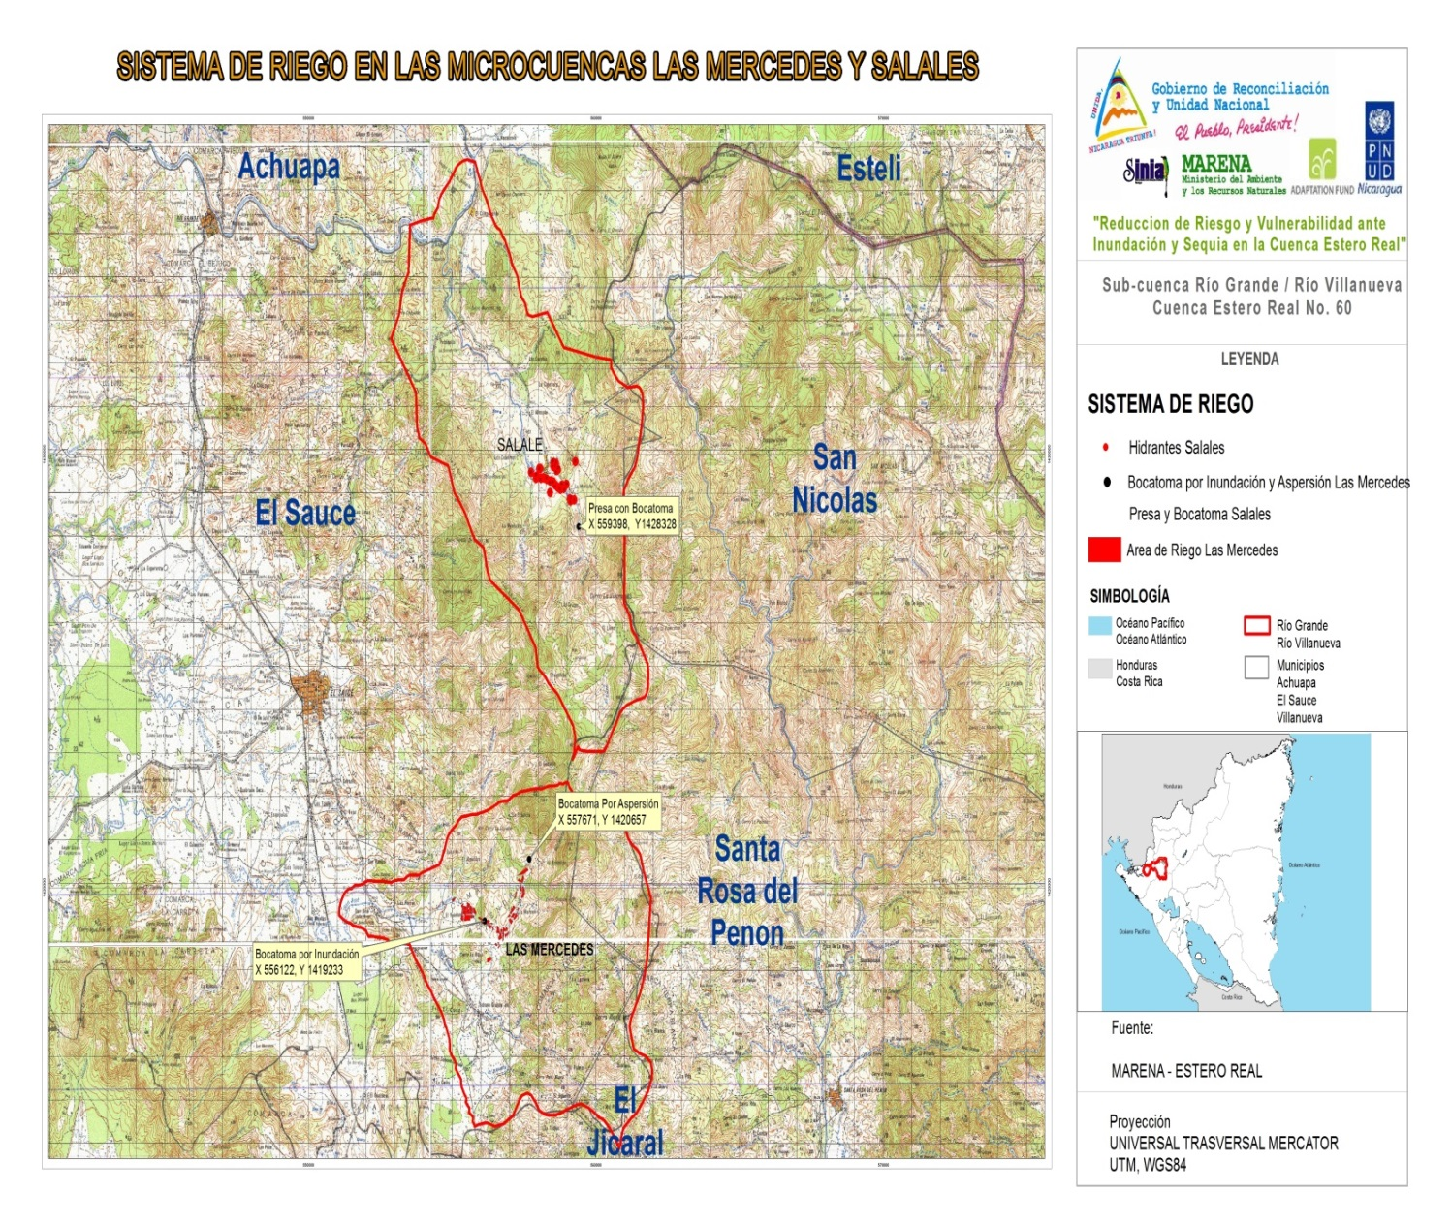

In Las Mercedes micro-basin, 56 ha. were under irrigation before; the project increased this area by 18 ha. for a total of 74 ha. under irrigation, registering an average of two crops per year since 2013 (See map below).

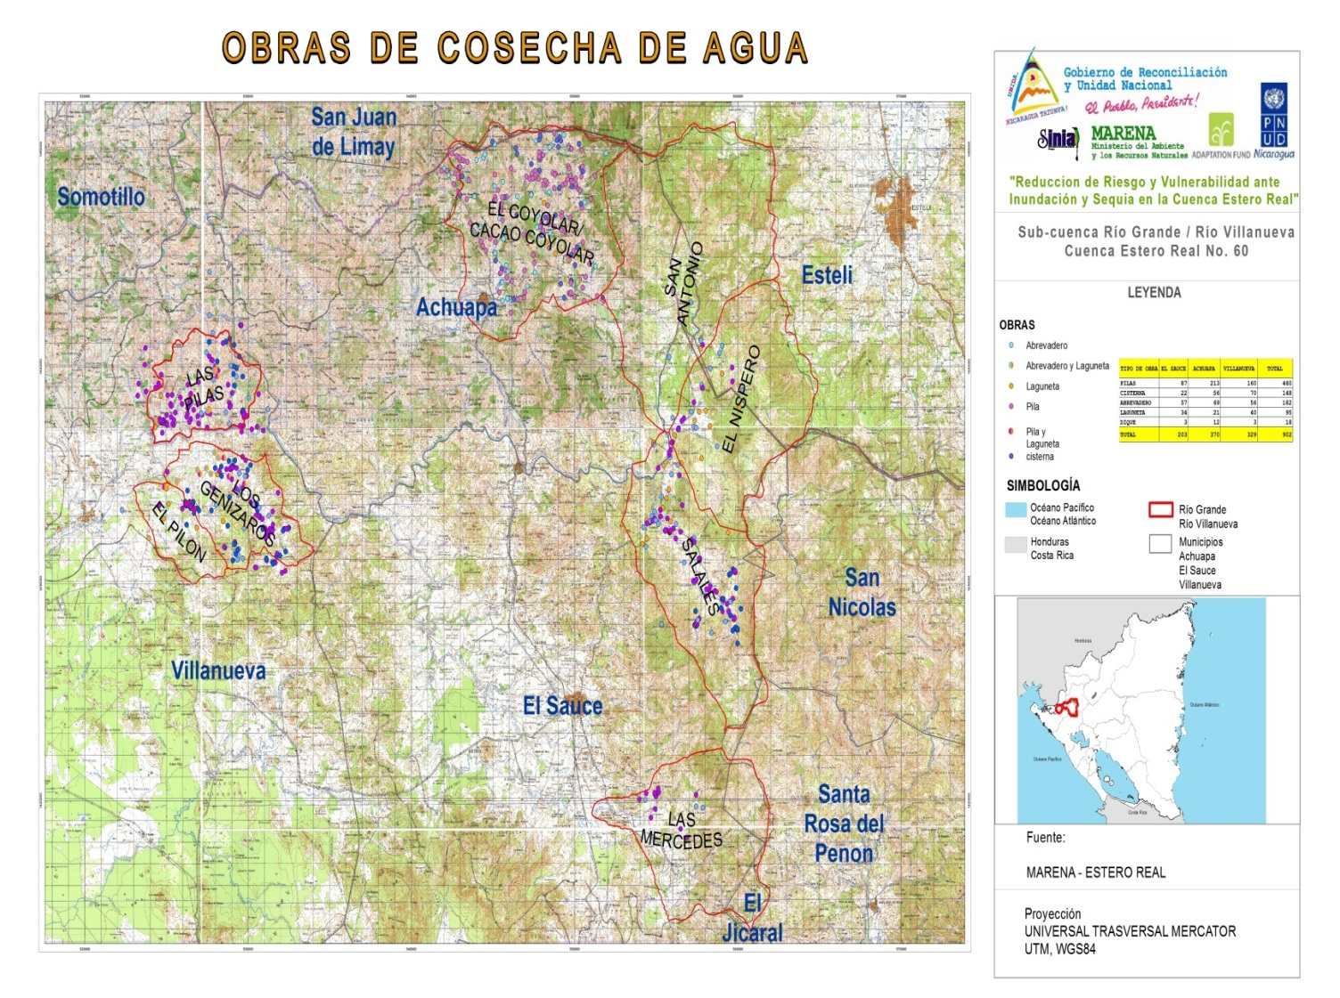

The community irrigation system in Las Mercedes micro-basin is made by two components: 1) The construction of a water collection structure in Mercedes Centro, which provides 30 lt. /sec. for sprinkler irrigation, providing benefits to 35 families. A 25 m³ tank, filled by the water collection structure, provides water for the cattle of 17 families and a washing area that is used by 22 women. 2) The water harvesting system of the Ismael Castillo cooperative receives 50 lt./sec. for flood irrigation through canals, serving 11 families.
The Salale dam was built to implement a community irrigation system, which irrigated 11.55 ha. for 20 families before the project and now irrigates 24.5 ha. with a capacity of 30 lt./sec, providing benefits to 32 families, and with perspective to triple the annual net income resulting from agriculture in an area considered of importance to feed the population of El Sauce municipality.
According to the IV National Agriculture Census of 2011, El Sauce, Achuapa and Villanueva had a total of 6,402 farms, of which 5,247 have access to some sort of water resource. Rivers and creeks are the main sources of water supply, as reported by 2,018 farms; 239 farms (4.5% of the total) had one or more irrigation systems, predominantly gravity systems used in 143 farms. 43 farms (0.8% of the total in the three municipalities) collect rainwater and 30 have dams, but none of these water harvesting facilities are located in the community under the program area of influence.
- About the Water Harvesting Works per Municipality in Achuapa, El Sauce and Villanueva:

- In Achuapa: Out of a total of 1,540 farms, 1,232 have access to some sort of water resource, being rivers and creeks the main sources of water supply. Of 633 farms reported, only 59 have one or more irrigation systems, being gravity irrigation predominant as it is used in 25 farms. Moreover, 18 farms collect rainwater and 9 have dams. None of this water harvesting facilities are located in the communities within the program area of influence.

- In El Sauce: Out of a total of 2,745 farms, 2,265 have access to some sort of water resource, being rivers and creeks the main sources of water supply. Of 643 farms reported, only 90 have one or more irrigation system, being gravity irrigation predominant as it is used in 48 farms. Moreover, 25 farms collect rainwater and 12 have dams. None of this water harvesting facilities are located in the communities within the program area of influence.

- In Villanueva: Out of a total of 2,117 farms, 1,750 have access to some sort of water resource, being rivers and creeks the main sources of water supply. Of 742 farms reported, only 90 have one or more irrigation system, being gravity irrigation predominant as it is used in 70 farms and 9 collect rainwater, but none of this water harvesting facilities are located in the communities within the program area of influence.

Results by type, municipality and community:
At the end of the program, 902 water harvesting structures have been constructed, which collect 175,455 m3 of rainwater for production and domestic use in 29 communities of the municipalities of Achuapa, El Sauce and Villanueva; these facilities benefit the same number of families who had no access to this infrastructure in 2011, which represents 102% of the initial goal.

The structures are distributed as follows:
- Achuapa: 17 pools, 72 channels, 24 cisterns, 38 troughs and 6 dams built in the communities of San Nicolas, Lagartillo, Las Brisas, San Antonio, Varela, El Waylo, Guanacaste, Las Lajas, Río Arriba, Las Tablas and Rodeito.
- Villanueva: 24 pools, 43 troughs, 47 cisterns and 21 troughs in the communities of Los Genízaros, Los Tololos y San Ramón.
- El Sauce: 24 pools in the communities of Petaquilla, Campamento y Nacascolo Norte.

Increased adaptation capacity
In summary this component has made that 1,005 families in 29 communities of the municipalities of El Sauce, Achuapa and Villanueva increase their water supply by 175,455 m³ for production and domestic use during the crop cycle and for livestock consumption. IN 2015 these families have enough water to ensure at least one harvest per year and have adopted agro-ecological practices through which an increase in crop yields and soil improvements in the mid-term are expected. This will reduce the risk of water shortage caused by climate change and variability.

As a complement, it is expected that the concentration of investments in water-harvesting facilities in the eight micro-basins in the upper area of the Villanueva River sub-basin have a cumulative effect in the reduction of soil erosion and sedimentation. This will facilitate the planning of investments aimed at halting devastation caused by floods in the middle and lower basin of the Estero Real River, in the municipalities of Villanueva, El Viejo, Puerto Morazan, Tonala and Somotillo.

RESULT 2
Increased eco-systemically resilient agro-ecological practices for effective use of water available in the eight target micro-basins.
Baseline for this result
Agricultural practices in the Estero Real River basin, where 46% live in extreme poverty, have altered the adaptability of the production scenario. Although there were some effort to promote more sustainable land management approaches through different projects in 2010, the farmers' vision was more focused on short term returns without understanding the current risk posed by climate variability or the long-term threats of climate change. Water stress is constant during the dry season and droughts related to the recurring event of El Niño-La Niña (ENSO) which affects agricultural production and food security.

Groundwater extraction does not take into account replenishment rates; deforestation, loss of mycorrhizae and loose or highly compacted soils limit water infiltration. During the rainy season, heavy rains cause recurrent floods and increased runoff, progressively sweeping the remaining productive soils.
Assessment of the outputs related to this Result
This component supported the preparation of 1,005 agro-ecological farm transformation plans, the actions for establishing agro-ecological production areas in each micro-basin as well as the delimitation and protection measures in riparian and groundwater replenishment areas.

TABLE 6. Summary of compliance with goals of Result 2 according to the Logical Framework
INDICATORS | BASELINE | EXPECTED OUTPUTS (GOALS) | ACTUAL OUTPUTS | COMPLIANCE AND EXPLANATION OF CHANGES
f) Percentage of rural families implementing agro-ecological farm transformation plans in each micro-basin. | 5%* | 80% of families | 100% | Goal attainment: 100%  There was no variation in relation to the number of families with agro-ecological farm transformation plans developed and implemented.
g) Number of rural families with agro-ecological farm transformation plans. | 0 | 1,005 farmers with plans | 100%
h) Area, in hectares, under agro-ecological transformation plans. | 0 | 1,120 Ha With plans | 100% | Goal attainment: 199%  The reason for this variation (1,115 ha) is that protagonists, empowered during the process of change, expressed their interest in increasing from 1 to 3 ha. the silvopastoral areas.
i) Increase in the percentage of land covered with plants in each micro-basin. | 25%* | 50% (At least 200 ha. of the areas with forest in riparian and aquifer recharge areas. | 100% | Goal attainment: 502%  The variation is due to the empowerment achieved by protagonists in protecting and preserving Mother Earth, which helped to increase the size of aquifer recharge zones (1,785 ha.) and riparian areas (223 ha.)
j) Area in hectares of protected forests in aquifer recharge and riparian areas. | 0 | 400 Ha. | 100%

Description of outputs associated to Result 2:
At the end of the program, a total of 1,005 agro-ecological farm transformation plans have been formulated, equivalent to 100% of the total planned: 375 in Achuapa, 270 in El Sauce and 275 in Villanueva. The formulated plans facilitated the agro-ecological transformation of 2,235 ha. exceeding the expected goal by 199% at the end of the program.

There is a total of 2,008 ha. of riparian and forest areas for aquifer recharge in the eight micro-basins defined, exceeding the expected goal by 502% at the end of the program In addition to natural regeneration management, it was possible to eliminate agricultural burnings and build barbed wire fences to protect areas from animals and intrusion (See map below).

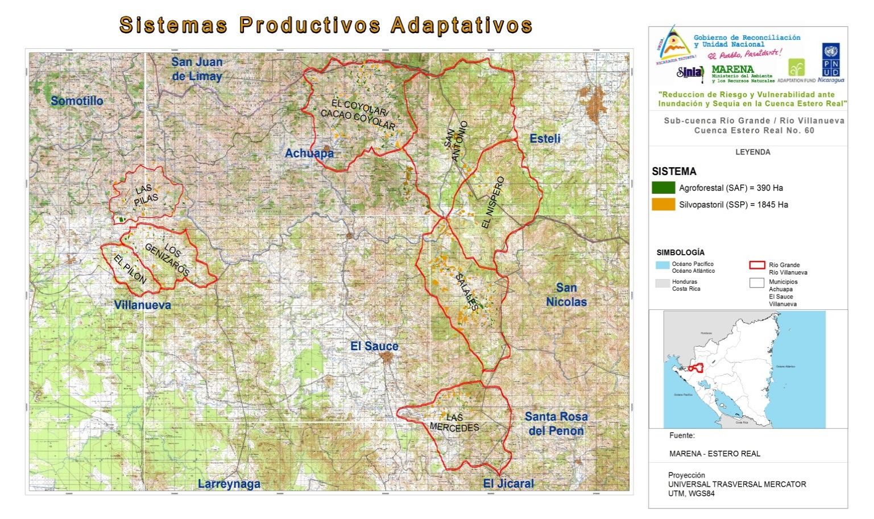

One of the fundamental pillars of the program was the integration of families in the implementation of 1,005 agro-ecological farm transformation plans in the eight micro-basins of the El Sauce, Achuapa and Villanueva municipalities, through investment in improved stoves (250 families in Achuapa, and 152 in Villanueva) chicken coops (232 families in Achuapa and 182 in Villanueva) and pigpens (90 in Achuapa and 113 in Villanueva) (See map below)

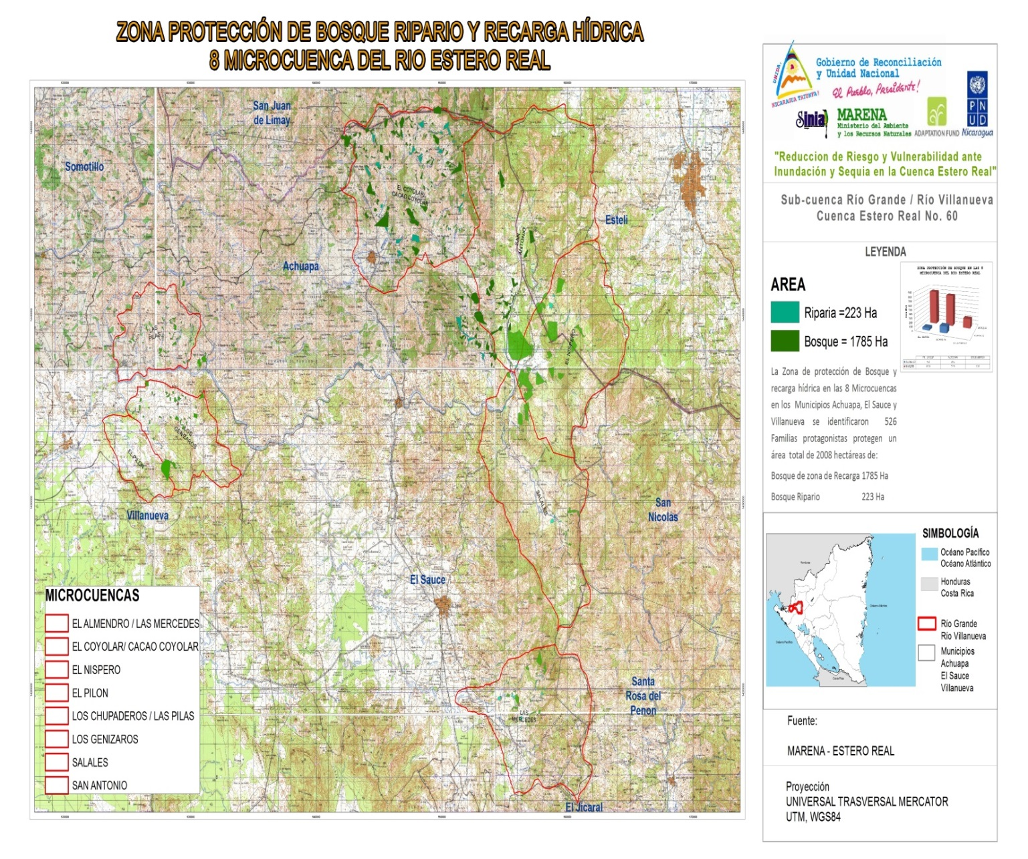

Increased adaptation capacity
In summary this component has achieved the implementation of agro-ecological practices by 1,005 rural families concentrated in eight micro-basins selected according to their importance for collective adaptation to the effects of climate change in the Villanueva River sub-basin. In terms of coverage, the program managed to benefit 16% of the total 6,394 farmers developing agriculture and cattle raising activities in the municipalities of El Sauce, Achuapa and Villanueva.

The increased forest coverage is expected to help: (i) increasing water infiltration; (ii) reducing runoff; (iii) reducing erosion; and (iv) anchoring slopes to reduce the risk of landslides and control in this way atypical water flows to protect people, homes, schools, health care units and facilitate the transportation of products in case of floods, mudslides and landslides.

The program has improved the capacity and knowledge of 1,005 families about the implementation of better agro-ecological practices and about the importance of protecting aquifer recharge areas and river side forests in the eight micro-basins of the Villanueva River.

RESULT 3
Strengthened the institutional capacity for incorporating climate change risk management in work plans, policies and policy instruments in the Villanueva River sub-basin and the Estero Real River basin.

Baseline for this result
The Estero Real River basin lacks a Management Plan for co-management of climate change adaptation that contributes to increase retention and protection of water; the conservation and enrichment of soils; and the land management that corresponds to the current reality. There is only a shared vision of what the reality should be and a transition plan for a temporary period determined by the community.

At municipal level, although adaptation to climate change is recognized as an important topic, it has not been incorporated in municipal plans and inter-institutional strategies. In the municipalities of El Sauce and Achuapa, most members of the Production Cabinets have participated in workshops aimed to prioritize the topics of water management in the micro-basins making up the upper basins of Rio Negro and Villanueva Rivers.

Assessment of the outputs related to this Result
This component supported the preparation of plans for micro-basins and the Villanueva River sub-basin. This process has been complemented with the municipal plans for environmental protection to climate change, implemented by families in eight municipalities of the Estero Real River basin: Larreynaga, Achuapa and El Sauce in the department of Leon; and Villanueva, Chinandega, Somotillo, El Viejo and Puerto Morazán in the department of Chinandega.

TABLE 7. Summary of compliance with goals of Result 3 according to the Logical Framework
INDICATORS | BASELINE | EXPECTED OUTPUTS (GOALS) | ACTUAL OUTPUTS | COMPLIANCE AND EXPLANATION OF CHANGES
i) A proposal validated and endorsed by three municipal governments to make the Rio-Villa Nueva Sub-basin Committee operational. | 0 | 1 | 1 | Goal attainment: 100%  There was no variation.
j) Municipalities in the basin with measures for climate change adaptation included in their official plans and relevant policy instruments. | 0 | 9 | 8 | Goal attainment: 100%  The variation was caused by the fact that only 8 of the 9 municipalities planned had direct access to the Rio Villanueva sub-basin (Larreynaga, Achuapa and El Sauce in Leon, and Villanueva, Chinandega, Somotillo, El Viejo and Puerto Morazán, in Chinandega).
Source: MARENA, 2015

Description of outputs associated to Result 3:
At the end of the program eight micro-basin committees have been organized in Achuapa (2) El Sauce (3) and Villanueva (3), which is equivalent to 100% of the total planned. The committees were formed through 24 community meetings and they are duly registered in the National Registry of Water Rights (RPNDA) which makes them legally constituted to initiate functions. These activities were implemented in close coordination with the National Water Authority (ANA).

Based on the official methodology of the Ministry of the Environment and Natural Resources (MARENA) to formulate municipal plans for climate change adaptation, the eight municipalities in the Estero Real River basin developed their municipal plans of environmental protection from climate change: Larreynaga, Achuapa and El Sauce in the department of Leon; and Villanueva, Chinandega, Somotillo, El Viejo and Puerto Morazan in the department of Chinandega.

Increased adaptation capacity
In summary, this component has made that families and communities in the municipalities of El Sauce, Achuapa and Villanueva develop management plans for eight micro-basins, and municipal plans for family environmental protection from climate change, which allow them to continue implementing measures for climate change adaptation and increase water harvesting, protecting water sources, preserving soils and achieving food security.

RESULT 4

Disseminated the results and lessons learned about the development of climate change resilience in vulnerable rural communities. This will be based on a permanent monitoring and analysis of weather conditions, changes in land use, water flows and soil quality.

Baseline for this result
Although SINIA effectively collects data, maps and national reports generated by MAG, INETER, and the MARENA territorial delegation and projects, this system has not yet managed to link their IT management capacity directly with the community processes to develop and implement land and water use plans at farm, micro-basin and sub-basin levels.

Assessment of the outputs related to this Result
This component supported the operation of eight environmental information nodes, the preparation of a hydrological study in the medium-lower area of the Estero Real River basin conducted by INETER, and the dissemination of environmental information on climate change and the measures proposed by the Government of National Reconciliation and Unity.

TABLE 8. Summary of compliance with goals of Result 4 according to the Logical Framework
INDICATORS | BASELINE | EXPECTED OUTPUTS (GOALS) | ACTUAL OUTPUTS | COMPLIANCE AND EXPLANATION OF CHANGES
Hydrological Study and number of Newsletters to disseminate the participatory monitoring of water quantity and quality, soil conditions and changes in use. | 0 | 1 | 1 | Goal attainment: 100%  There was no variation.
The lessons learned in the eight micro-basins and the Rio Villanueva sub-basin are available in SINIA and other websites (ALM) and are disseminated through exchange workshops. | 0 | Update FA and MARENA websites with 4 annual and 12 quarterly reports. | Designed and published on-line the FA and MARENA websites; 4 annual and 12 quarterly reports. | Goal attainment: 100%  There was no variation.
Source: MARENA, 2015

Description of outputs associated to Result 4:
At the end of the program, there are relevant geo-bio-physical and meteorological data collected and analyzed by INETER and they are available for the Rio Villanueva sub-basin. This study has allowed to identify the causes of floods in the lower area of the Rio Estero Real basin since Hurricane Mitch in 1998 (See map below).

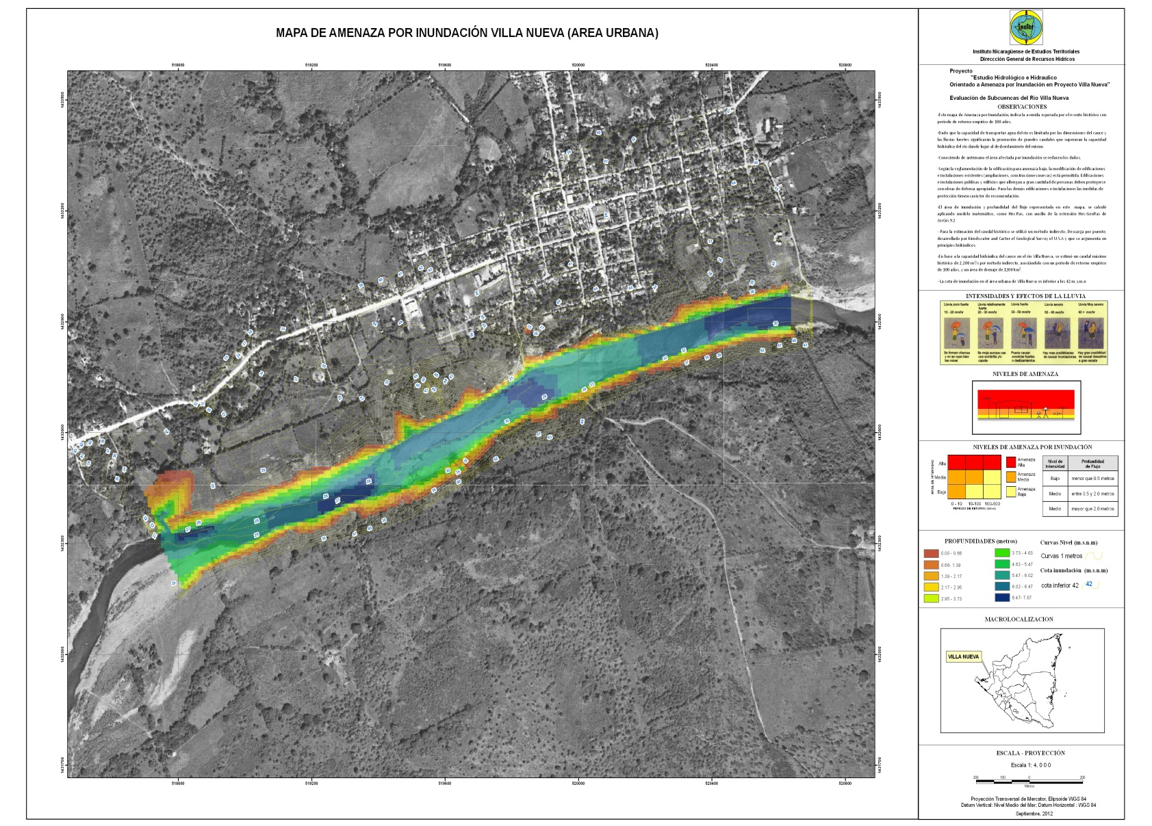

An electronic information office was established in each micro-basin and eight technicians from every municipality in El Sauce, Achuapa and Villanueva received computer training to produce and analyze digital maps of the current land use, delimit aquifer recharge areas and collect monitoring information on water volumes and areas for natural forest regeneration. During the program implementation, the information offices kept an interactive communication with the regional node of the National System of Environmental Information (SINIA) located in the MARENA Departmental Delegation in Leon.

The progress and achievements of the program have been disseminated through the following instruments:

- The government promotes the construction of environmentally friendly stoves. On-line Environmental Newsletter, MARENA, issue 33 (January 2013).
- Nicaragua is working to reduce risks and vulnerability caused by floods and droughts in the western region of the country. On-line Environmental Newsletter, MARENA, issue 35 (March 2013).
- MARENA website (www.marena.gob.ni) and SINIA website (www.sinia.net).

However, this component is the weakest of the four mentioned in the approved program document, since both the websites of SINIA and the North Pacific Node present limited information to keep the families in the basin informed about the SINIA maps and the project node. There is also limited information from the monitoring system and from the continuous analysis of the climatic conditions and changes in land use, the water flows and soil quality in the basin.
Increased adaptation capacity
In summary, this component made possible a hydrological study of the lower area of the Estero Real River basin, which has allowed to identify the necessary water works to reduce floods caused by sediments accumulated in the upper area of the Villanueva River sub-basin.
1,005 families have strengthened their capacity to monitor water levels and quality, soil conditions and changes in land use at farm and micro-basin levels.
Information of the eight micro-basins in the Estero Real River has been produced, and the results and lessons learned about development of measures for adaptation to climate change in vulnerable rural communities can be transmitted to the national level.

3.3. EFFICIENCY.

Efficiency determines if the resources/inputs (funds, time, etc.) have produced project results. This criterion is usual in the cost-benefit analysis made in the final evaluation.

The final evaluation considers that the program benefits were greater than costs and that goals were achieved at a reasonable cost. Moreover, according to Table 9 the financial execution achieved 100% as all planned resources were used on time.

TABLE 9. SUMMARY OF THE 2011 - 2015 FINANCIAL INFORMATION FOR THE ESTERO REAL PROGRAM

Components | Planned in PRODOC in US$ | Total Executed in US $ | % of Execution vs Planned
1 | 2,480,000.00 | 1,943,654.49 | 78%
2 | 1,300.000.00 | 1,483,865.25 | 114%
3 | 400,000.00 | 397,743.02 | 99%
4 | 440,000.00 | 761,909.13 | 190%
5 | 450,000.00 | 482,478.60 | 107%
Total | 5,070,000.00 | 5,069,650.48 | 100%
Exchange difference |  | 349.52
Total  General | 5,070,000.00 | 5,070.000.00 | 100
Source: MARENA 2015
The difference in component 1 is due to the reduction in costs for the construction of the two community irrigation systems, since the original designs in the Program document were adapted.
The difference in component 2 is due to the increase in the estimated costs for procurement of inputs, specifically vegetative matter and hardware for the protection of the aquifer recharge areas and construction of improved stoves.
The difference in component 4 is due to the acquisition of goods for an amount of US$286,413.34, which will further strengthen the institution to achieve the sustainability of the project actions in its influence area.
3.3.1 The role of the Model of Alliances to achieve greater efficiency.
According to the midterm evaluation and evidences analyzed for the final evaluation, the success in the program efficiency is due to the Model of Alliances and Shared Responsibility implemented by the Government of National Reconciliation and Unity which entails mechanisms and procedures that maximize the execution, administration and implementation of the program actions since its inception.

The program was successful in promoting and establishing collaboration agreements and alliances for prosperity, which enabled the creation and legalization of eight micro-basin management committees, one sub-basin committee and two irrigation committees. It also allowed coordinated action by national and local stakeholders through institutional agreements (MARENA-INTA; MARENA-ANA; MARENA-UNAN - Leon; MARENA - INETER; MARENA-MAG; and MARENA-local governments of Achuapa, Villanueva and El Sauce).

The very close collaboration with the local governments allowed to implement important activities for basin management, like the selection of protagonist families, selection of micro-basins, establishment of environmental restoration systems, selection of sites for community irrigation systems, training and awareness-raising processes, and the participatory monitoring of the climate conditions for basin management.

The collaboration of INETER, ANA and MARENA with the project made possible a change of approach in planning, from departmental to basin and sub-basin levels, as established in the National Water Act. ANA give priority to the approval of Micro-basin and Sub-basin Committees in compliance with Law 620 or the National Water Act. MEFCCA activities are complementary to the project and there are overlaps in key stakeholders' focus in micro basins and sub-basin.
With INETER, it was possible to join efforts to make the Hydro-meteorological Study of the Estero Real River Basin and the maps of soils, potential land use and conflicts around land use.

With MEFCCA, the program had a close relationship focused on food security due to the increased availability of irrigation water. Also, with INAFOR joint work was developed to manage the aquifer recharge and riparian areas, and the forest plantation management. With INTA, the program carried out complementary activities in the community irrigation systems.

With universities, there was a close relationship to provide pre-professional training to Agro-Ecology students, conduct a social audit in the program area of influence, and create a diploma in planning and management of natural resources for climate change adaptation.

The institutions involved in implementing the program effectively contributed to do their duties, in a process coordinated by MARENA to implement the government strategies, and promote water and environment management and adaptation to climate change with a decentralized approach. In general, the technical assistance and studies conducted by these institutions (like INETER, INATEC, ANA and MARENA) effectively contributed to achieve the expected outputs and offered excellent input to achieve the program expected results.
3.3.2 Overall rating of the program in terms of relevance, effectiveness and efficiency.
The final evaluation assess as Satisfactory the program impact in terms of relevance, effectiveness and efficiency, since the risks of droughts and floods generated by climate change and variability for 1,005 families from 29 communities of the municipalities of El Sauce, Achuapa and Villanueva - located in the Estero Real River basin - have been reduced at the end of the program.

3.4. SUSTAINABILITY.

3.4.1 Financial and economic dimension.
According to the midterm evaluation and until the end of the program, the financial and economic sustainability was properly addressed. The final evaluation identifies no financial or economic risks that could endanger the program sustainability and results.
Once the FA funds available are spent, the municipal governments of El Sauce, Achuapa and Villanueva will use part of the national budget transfers received from the central government to finance actions included in the municipal plans for environmental protection of families to climate change.
However, there are actions derived from the municipal adaptation plans for which the National Government will seek international financial resources in order to facilitate their implementation. For example, it is necessary to seek financial support to implement a National Irrigation Plan, which will enable the country to largely overcome climate variability in precipitations, including the eight municipalities of the Estero Real River basin as part of the country's dry corridor: Larreynaga, Achuapa and El Sauce in Leon; and Villanueva, Chinandega, Somotillo, El Viejo and Puerto Morazán in Chinandega.
According to the financial reports, the program accountability was conducted transparently and with the technical knowledge required for financial operations.

3.4.2 Socio environmental and political dimension.
From the results achieved by the Program of reduction of risks and vulnerability to floods and droughts in the Estero Real River basin, it can be concluded that there was a good process regarding the real participation of communities, institutions and local organizations involved in the program implementation, both in the municipalities of Leon located in the upper basin (El Sauce and Achuapa) and in Villanueva, located in the lower basin in Chinandega (source: Social Audit Report, MARENA).
Sustainability depends on the degree of empowerment achieved by the families participating in the program as a result of the accomplishment of the objectives under the model of alliances and shared responsibility of the Government of National Reconciliation. Once empowered, these families will continue the activities implemented with their own resources and with follow-up provided by the institutions that have a strong presence in the territory, including INTA, MAG, MEFCCA, the community assistance program of the local governments through the Production, Consumption and Commerce Cabinets, and MARENA through the social policy structure, which has been strengthened with actions to prevent fires and monitor the biodiversity corridors.
According to the MARENA social audit, conducted by UNAN Leon for the program, the participatory methodology allowed to find that protagonists developed a vision of care and protection of water sources through the main water harvesting works for farms irrigation. After realizing that their food, production and income depend on this vital liquid distributed through the community infrastructure, they found necessary the organization and strengthening of water management and irrigation committees for proper management of the infrastructure and secure water flows in rivers (Salale and Las Mercedes).
Interviews and dialog with families in house-to-house visits allowed to verify that a process of attitude change has already begun, with good prospects for local environmental promoters and the institutions with presence in the department that contribute to the process of change: burnings for land preparation and forest fires have decreased approximately by 85% (source: SINIA heat monitoring stations and the seasonal report of the fire commission, CODE SINAPRED 2014 -2015).
In the process of dialog and talks, the protagonists have reported a reduction in use of agrochemicals in crops and soil, explaining the chemicals contaminate the soil and water in their wells.
One of the sustainability indicators identified by the program is precisely the number of protagonists that participated and currently participate in the different activities implemented by government institutions to promote and disseminate the use of natural agricultural supplies; the farm results from using agro-ecological environmental restoration systems and water provision infrastructure; and the participation of farmers in the organizations and associations members of the municipal cabinets for production, consumption and commerce, among other processes related to the different programs and projects aimed at promoting agro-ecology and productivity.

3.4.3 Institutional framework and governance.

The program is based on a Christian, Socialist and Solidarity model implemented by the Government of National Reconciliation and Unity since 2007, complemented with alliances between institutions of the National Government, like MARENA, MAG, MEFCCA, INTA, INAFOR and INTUR, which is implemented in the Estero Real River basin through the municipal governments of El Sauce, Achuapa and Villanueva and the Faith, Family and Community Model that has supported and will continue to support the implementation of technologies, tools and procedures for climate change adaptation by individuals, families and communities in those municipalities.
According to the midterm evaluation and until the end of the program, there is evidence of financial sustainability and strong evidence of institutional sustainability, considering the political-institutional commitment that supported the program, which may be easily replicated beyond the program activities.
The results obtained indicate that in general, farmers and organizations have successfully developed ownership on the adaptation and management process at micro-basin level in their plans, strategies, and behaviors. Therefore, the protagonists change in behavior indicate that this approach might be replicated in other regions of the country, allowing the program results to be sustainable.

3.4.4 Environmental Dimension.

The Hydro-meteorological Study conducted by INETER in the Estero Real River Basin, as part of the program alliances framework, provides evidence that in the short term there is no environmental risk threatening the sustainability of its results. This study addressed the impact of climate change on water resources and the vulnerability to drought as an environmental threat in the short, medium and long terms, considering the analysis effects and its adaptation alternatives for 2030 - 2050.

3.4.6. Overall rates.

The final evaluation considers the program sustainability as Somehow Probable (SP), since there are moderate risks that might affect the analyzed sustainability dimensions.

IV. EVALUATION OF THE PROCESSES THAT CONTRIBUTED TO ACHIEVE THE PROGRAM RESULTS.

The evaluation of the processes that influenced the achievement of the program results aims to identify and present the experience obtained by the population and families in the municipalities, within the capacity building process around this topic, and how the lessons learned from other actions in the municipalities (previous projects) contributed to the implementation of our program and were included in the design and directly in its implementation.
The role of the local communities as protagonists of their own changes, under the great model of alliances and share responsibility promoted by our Government of National Reconciliation and Unity, has been important, including actions like the inclusion of Youth and Women through a gender focus. The fiduciary responsibilities of the project, the financial controls, audits and arrangements for program management were also evaluated.
The criteria considered for the processes that influenced changes are presented below:

4.1 Lessons from other projects used for the design and implementation of the program.
To design the project, lessons learned from previous experiences and data obtained from other projects were used. The program used validated methodologies from the Sustainable Land Management Project (MST-MARENA) to introduce agro-ecological practices with farming families living in the eight micro-basins selected, considering their importance for collective adaptation to climate change effects in the Villanueva River sub-basin. The model for farm agro-ecological planning was taken from the Socio-environmental and Forestry Program (POSAF-MARENA).

Through these alliances, the program encouraged the implementation of new national agro-ecological policies and helped to institutionalize the results of previous projects, using existing teaching materials, introducing validated agro-ecological practices and establishing agreements between government institutions, including INTA, MAG, ANA, INETER, Municipal Governments and UNAN-Leon.

4.2. The role of local communities in the program.
Under the current model, "the People, the President", promoted by the Government of National Reconciliation, organized people has the power to be protagonist of their own history, making decisions that affect their economic, political, social and cultural life.
This means that direct democracy promotes profound processes of change in society, based on awareness of people's capacity to exercise power and the promotion of ethical and moral values conducting to true human development.
Direct democracy is a strategy to achieve the economic, political and social changes necessary to democratize the country and reduce inequalities to overcome poverty, which will allow people to be part of the successful implementation of policies and programs aimed at these purposes.
The Citizens Power Cabinets and Community Councils are active and direct participatory forums gathering different sectors of the country, elected democratically, without political, social, religious or gender discrimination. They participate actively in identifying and prioritizing their problems, in local management and the comprehensive development of communities, villages, territories, municipalities, departments and nation.

During its implementation, the program worked with 29 communities from eight micro-basins, investing in water-harvesting, long-term farm planning, establishing agro-ecological practices, micro-basin and sub-basin planning and developing the protagonists' capacity in these local communities. The program validated with these communities an adaptation scheme as a means for implementing the National Strategy for the Environment and Climate Change.

The program worked with the irrigation committees of Salale and Las Mercedes, farmers' families, community organizations, Cabinets of Citizens' Power, Groups of Women and the Guardabarranco Youth Environmental Movement. A committee was also organized for each of the eight micro-basins and the Villanueva River sub-basin, with whom micro-basin and sub-basin management plans were formulated. This process was supported by MARENA and formalized by the National Water Authority (ANA).

Throughout the process of implementing the program, the point of view of the protagonists, community leaders, micro-basin and sub-basin committees, Cabinets of Family, Community and Life, irrigation committees and all those affected by the program decisions were taken into account for decision making. A process of consultation with the local communities was conducted during the studies to design the water harvesting works in 2008. As a result, two irrigation association were defined, and agreements were made on their creation and operation upon the completion of the systems. These agreements included a definition of procedures for allocation of water rights.

4.3. Inclusion of Youth and Women through gender practices.
Under a collaboration agreement between MARENA, the National Autonomous University of Nicaragua (UNAN-Leon) and the municipal governments of El Sauce, Achuapa and Villanueva every year of the program execution, 30 Agro-Ecology students carried out pre-professional internships in the program's area of influence.

Teaming up with extension workers and information nodes, four agro-ecology students on average were located in each micro-basin, where they lived with farmers for one month, providing support for the elaboration, implementation, monitoring and annual update of the farm transformation plans.

Farmers' families committed to the project actions in the communities provided accommodation and food to the students during their time in the community, which ensured an exchange of customs, traditions, knowledge and culture; the presence of these students facilitated the families and communities involvement around the different measures for adaptation to climate change, and provided support for appropriation and empowerment.

At community level, the program had the solidarity of young people organized in the Guardabarranco Environmental Movement and the Sandinista Youth July 19, who actively participated in the processes of awareness raising and training, the reforestation of riparian and aquifer recharge areas and in delivering materials to protagonists, which resulted in a much more aware group of young people, who are expected to support the sustainability of the environmental actions in the future.

Enforcing the national policies that highlights the role of women in rural areas, a gender strategy was developed and implemented, which allowed to create opportunities for women participation so they could have a stake in decision making as well as in control and access to the program resources.

Of a total of 1,005 farmers with agro-ecological transformation plans, 19% are women; 77% of the 792 families benefited with the construction of water harvesting works are women; and 30% of the 117 families with irrigation systems in Las Mercedes (85) and Salales (35) are women.

Women also participated in the following organizations and investments as protagonists:

- 38% of the members of the micro-basin committees are women.
- 43% of the members of the Villanueva River sub-basin committee are women.
- 75% of the protagonist women use improved stoves, which reduce workload at home and pressure on forests.
- Access to resources by women through the construction of 721 chicken coops and 331 pens for chicken and pigs.
- Improved food and nutrition security, and generation of income through the provision of fruit plants, mainly to women who invest time and resources in the backyard economy, giving them more independence in the use of income.

In every micro-basin, workshops, fairs, discussions and exchanges were implemented to promote analysis of the roles in the production process and the family economy of men, women, youth and children, recognizing the value of domestic work, the marketing of products and the production through family vegetable gardens.

Evidence confirms the program's emphasis on the importance of comprehensive practices for production systems that will encourage family participation. Inhabitants in the micro-basins were included regardless of their economic status and diversity of political beliefs.

This resulted in the promotion of a more just and supportive relation between men and women, adults and young people, creating conditions and values that enable capacity building and a more equitable distribution of roles among family members. This also resulted in a process of latent energy release in rural families, so women and young people currently implement changes in favor of ecology, food and nutrition security and sovereignty, and biodiversity.

Finally, it can be confirmed that in the 29 communities covered by the program, women have a leading role in their farms, families, the Cabinets of Family and Community, in the management of social and environmental projects and in the micro-basin and sub-basin committees.

4.4. Financial controls and audits
The program implemented adequate financial controls, which were in line with the policies and procedures of UNDP as implementing agency, and included the presentation of reports and plans that enabled the Project Management and Coordinating Unit to make informed decisions on the budget and timely flow of funds. All the financial information was recorded in the Administrative and Financial Division of MARENA as CDR (Combined Delivery Report) which are the UNDP official documents.

During the program lifetime, two financial audits were conducted (2013 and 2014) in accordance with the International Standards on Auditing (ISAs) promulgated by the Council of the International Federation of Accountants (IFAC) and the INTOSAI Standards. These standards require that audits be planned and conducted to obtain reasonable assurance that Financial Statements of projects or audited institutions in a given period do not contain significant errors or omissions.

The two audits found no anomalies causing prejudice for the project, the laws and regulations applicable to financial statements. These audits included examination based on selective tests of the evidences supporting the amounts and disclosures in the financial statements. These audits also evaluated the accounting standards applied and the significant accounting estimates made by the Management, as well as the evaluation in the presentation of Financial Statements.

The expense report was prepared on the basis of disbursements or total expenditure incurred for project implementation, in accordance with the International Public Sector Accounting Standards (IPSAS) adopted by UNDP since 2012.

4.5. Program Management Arrangements
MARENA as implementing entity was responsible for ensuring that the defined objectives and results were achieved and that the resources were allocated as indicated in the Program Document. Similarly, MARENA ensured effective coordination between the program and other relevant projects in Nicaragua.

UNDP as implementing agency conducted the internal monitoring and the evaluation activities for the program, taking into account, from the outset, the local capacity, the limitations and needs to manage the program, as well as the effectiveness and efficiency of communication among the Ministries and the other institutions relevant for the program.

V. PROGRAM CONTRIBUTION TO THE OBJECTIVES, GOALS AND IMPACTS OF THE ADAPTATION FUND (AF)

The AF (Adaptation Fund) policies establish that a concrete project and/or program is defined as a set of activities aimed at addressing the adverse impacts and emerging risks posed by climate change, developing activities to generate visible and tangible results in practice, by reducing vulnerability and increasing the adaptive capacity of human and natural systems to respond to the impacts of climate change, including climate variability.
Under these AF principles, this final evaluation assess as Satisfactory the program contribution to the objectives, impact and goals of the Adaptation Fund.
The program was successfully implemented in Nicaragua as a developing country that is particularly vulnerable to the adverse effects of climate change and is member of the Kyoto Protocol. Through this program, the country was able to achieve the implementation of concrete adaptation measures and increase resilience to climate change among individuals, families and communities in the Estero Real River basin.
The program contributes to the AF priorities described below:
- Support the adaptation priorities determined internally by developing countries.
- Maintain consistency with the relevant national strategies on development, poverty reduction and climate change.
- Take into account the existing scientific and political orientations.
- Pay special attention to the specific needs of the most vulnerable communities.
The program has supported the implementation of the National Human Development Plan and the National Strategy for the Environment and Climate Change, coordinating government's efforts to implement the General Law on National Waters and the agro-ecological policies, which were supported by geographically concentrated investments to develop inexpensive water harvesting infrastructure and the national capacities for adaptation to climate change.
The experiences generated by the program are contributing to the creation of new policies and programs to reduce vulnerability to climate change such as the National Water Plan, the National Policy for Water Harvesting and the development of a National Irrigation Program.
The specific needs of the 29 most vulnerable communities in the municipalities of El Sauce, Achuapa and Villanueva were addressed through the implementation of 1,005 Agro-ecological farm transformation plans. A combination of new agro-ecological practices was promoted, using water collected in community irrigation systems and 902 rainwater harvesting facilities developed in the eight micro-basins of the municipalities of El Sauce, Achuapa and Villanueva to increase water supply for domestic and production use, reducing water deficit in 2,235 hectares and increasing crop yields.

This has reduced the risk of climate induced water shortage among 1,005 farmers and has developed individual and communal adaptation capacity to deal with climate change and variability in the long term.

According to the social audit conducted by UNAN-Leon in the program area of influence, 89% of women and 84% of men consider themselves prepared to deal with climate change. 97% of the respondents from both sexes, on average, considered that the adaptation practices improved the environment and the same percentage said to be satisfied with the program implementation. See Annex No.7

At micro-basin level, the Program managed to improve soil and water conditions through an increase in plant coverage in 2,008 ha. of riparian and aquifer recharge areas and 2,235 ha. of farming areas that changed to adopt agro-ecological production systems.

VI. ASSESSMENT OF THE MONITORING AND EVALUATION SYSTEM

6.1 Evaluation of the Program's M&E Plan.
The program final evaluation assesses as Satisfactory the M&E Plan for monitoring the results to achieve the program objectives. There were minor deficiencies in the design and implementation of the M&E system.

According to evidence presented, the monitoring component applied a monitoring and evaluation method to the project, based on attainment of the indicators included in the Logical Framework and the adaptive management in the planning process. This method was efficient in measuring the expected results since the program inception through its end, but it did not allow the automatic emission of alerts, which affected its functionality.

The meetings of the follow-up committees implemented by MARENA in all its projects were an instance that allowed to determine alerts and/or make necessary adjustments in real time to achieve the planned objectives.

Since its inception, the program M&E Plan was based on a management framework per results, giving priority to an approach based on results rather than an approach based on activities. The plan analyzed and registered effectively the progress in achieving the results and its correlation with the activities implemented; the monitoring scheme was focused on objectives, results, its corresponding indicators and measure of progress.

Similarly, the Program implemented the adaptive management approach focused on results (indicators of impact and systemic changes); adapting inputs and some activities in response to changes in circumstances, which was made in agreement between MARENA, UNDP and local stakeholders. (The main changes were described in number 4.2, Effectiveness). There were no changes at product and indicator levels for an effective M&E of the project.

According to evidence aimed at measuring attainment of indicators, the program team and the specialist responsible for the M&E component carried out field and desk work sessions; indicators were verified in the field through interviews to protagonists and visits to the production systems, community irrigation systems and rainwater harvesting works.

During each six-month period, the program team held work sessions to measure compliance with key indicators (results, outputs) generating reports on progress and results. A systematic collection of information was conducted, which documented the project progress at the end of the program.

The M&E Plan had a detailed schedule of activities including the budget for every year until the end of the program. After the initial workshop, the amount budgeted to implement an adequate M&E system was US$130,500.

The program progress was demonstrated through the following monitoring instruments: Inception Report, Quarterly Reviews and Reports, Annual Progress Reports (APR), Field Visits, Annual Operational Plans (for each year of the Project), Midterm Evaluation, Final Evaluation, Final Report and a document presenting the lessons learned.

6.2 Program baseline.

This project lacked a baseline study, which limited measuring the program contribution to the final results. However during its implementation, the farms situation before and after the farm management plans was monitored as well as the additional actions around the target areas, like the protection of riparian and aquifer recharge areas.
The program was designed with the participation of relevant local organizations in the Estero Real River basin, using local information obtained through a diagnostic and modified in the inception workshop. Information available in local governments and government institutions was also used.

The logical framework indicators were the main reference to measure the changes to advance the project results and objectives.

VII. LESSONS LEARNED AND ANALYSIS FOR SUSTAINABILITY.

7.1 Lessons learned

- Learning about adaptation to climate change has allowed protagonists to develop ownership over the project practices, methodologies and strategies to be used in their farms, which has resulted in an improved adaptive capacity.

- One of the best solutions to address drought and climate change is the location, design and construction of small individual and community works to collect and store rainwater. This process should be accompanied with the corresponding generation of capacities for an effective and adequate water management and maintenance of the works.

- Rainwater harvesting is an ancient technology, inexpensive and technically feasible, that can also be adapted to different social and environmental conditions. However, to maximize the impact of the rainwater stored, it is necessary to establish alliances for prosperity between national institutions and the local governments.

- The rainwater harvesting works allow a reduction of the negative effects of floods in the lower basin and the water collected produce direct environmental and economic benefits.

7.1.1 Uncertainty around Climate Change Impacts.
The final evaluation recognizes that climate change is cumulative and unpredictable, creating always uncertainty, which has a homogeneous impact in ecosystems and populations.

According to the V Report of IPCC (2014) for Central America, an average temperature increase of 3 degrees Celsius is expected at the end of the century, while rainfalls may decrease by 10%.

Nicaragua is the 4th most vulnerable country to climate change in the world according the Global Climate Risk Index (Germanwatch, 2015). In addition, between 1994 and 2013 it has been one of the countries most affected by extreme weather events.

Based on information and data obtained during the program implementation, it is probable that the impacts analyzed by INETER in the hydro-meteorological study of the Estero Real River basin happen in the middle-lower section of the basin, but with a lower level of intensity due to the benefits expected as a result of the measures implemented by the program in the upper basin.

The water harvesting works contribute to recharge aquifers, control erosion, develop wildlife, improve landscape in the area, contribute to food security and increase income among protagonist families.

At technical level, the efficiency of a number of forestry, agro-forestry and silvopastoral practices aimed at increasing plant coverage to reduce erosion and protect aquifer recharge areas was proved.

A farm plan allows the organization of a production unit and a better allocation of investments in agro-ecological transformation for adaptation, while identifying the needs of men and women. In this process, the participation of the whole family is very important since this allows full participation in designing the pathway to develop their production units and determine the resources to achieve it.

The environmental restoration systems (Agroforestry and Silvopastoral) are important to reduce the risks of droughts or water shortages in crops, since they create a microclimate that maintains soil and environmental moisture enabling harvests even if they are smalls.

Forest natural regeneration is much more effective for forests recovery and basin management than other methods. Direct planting of native forest seeds in the area is an effective method to implement natural regeneration.

The collection and direct planting of forest seeds is a silvicultural method of great impact, cheaper and easily adopted by the protagonists in charge of reforestation in riparian and aquifer recharge areas.

The alliances for prosperity achieved among different institutions during the program are very important to replicate the project experiences.

At organizational level, the micro-basin and sub-basin committees formed by local farmers, municipal representatives, governmental institutions and NGO's supporting production activities enable better coordination at all levels. These organizational and perceptual achievements, although difficult, are possible because the water topic is highly motivating for organization and empowerment in rural communities, especially when they share the same basin.

Water management is the factor that allows the organization of micro-basin and sub-basin committees, creating in this manner capacity to develop and implement micro and sub basin management plans to respond to climate change effects.

The effective participation of protagonists through committees to prepare micro-basin and sub-basin management plans allows participants to develop ownership on the strategies and their implementation to guide their decisions on the use of water and land resources.

The micro-basin and sub-basin management plans are the main instrument for adaptive co-management that allow to adopt a shared vision of the community to increase water retention and protection, soil preservation and enrichment, and land use planning.

The information offices in the micro-basins facilitate the development of capacities and information in the communities about extreme events, which work as early warning in case of seismic and climate events, disasters and calamities in general.

The information offices located in the micro-basins under the Faith, Family and Community Model enable the articulation of empirical knowledge and work methods with scientific methods, facilitating the commitment of community members to protect Mother Earth and reduce the risks of droughts and floods in the basins.

The appropriation and understanding of the gender practices is easier if this process is developed in the context of national policies that highlight the role of women in rural areas.

Responding to the practical needs that help women to improve their working conditions at home and yards is a step to advance strategic needs like access and control of resources and decision making.

The success of training processes depends on taking into account equally the needs and interests of women and men to ensure equal participation.

The lessons learned about gender should be capitalized in developing new programs, new initiatives, that reach a wider audience in Central America and beyond, including other donors and agencies involved in similar initiatives in other countries.

VIII. CONCLUSIONS AND RECOMMENDATIONS

8.1. Conclusions.
Considering the outputs and the achievement of its objective, the project overpassed many of its indicators and therefore it is considered satisfactory.
According to the Final Evaluation, the project is considered satisfactory and somewhat sustainable, as it achieved its objective, the country goals and the goals related to the Adaptation Fund.
The comparison between the final results with the reference and adaptation baseline produced at the program outset shows that the program increased livelihoods capacity to resist against threats among 1,005 protagonist families. This means that families are better prepared to successfully deal with droughts and floods, which are expected to be always present in the region.
The main learning goal of the project was the generation of knowledge on climate change adaptation in 29 communities. This allowed the appropriation of practices, methodologies and strategies and their implementation in farms to enhance the adaptation capacity.

8.2 Recommendations

- Use micro-drip irrigation in any irrigation system linked to rainwater harvesting facilities, which is more efficient and effective.

- Reforest through direct planting of forest seeds to increase the forest cover at lower cost in natural regeneration areas.

- Implement an Environmental Compensation Fund to protect and manage aquifer recharge areas and water sources.

- Establish basic hydro-meteorological stations in each micro-basin to register the weather conditions in the dry areas.

- Include research actions around topics relevant for the agro-ecological transformation through adaptation practices.

- Replicate the program results at least in the Hydrological Unit 58 of Río Negro (Code 9533762) and Tecomapa (Code 953374)

- Strengthen the participation of project protagonists in the different activities of promotion, dissemination, consumption and commerce of organic products produced on the farm, as well as to choose a market for production surplus.

- An important number of protagonists achieved and are in process to develop an agro-ecological vision, which needs to be completed to achieve better results in terms of productivity and marketing. For this reason, it is recommended that the database of these protagonists be shared with other government institutions to take advantage of the strengths, in programs of food security and farmers adaptation to climate change. It is also recommended to promote exchanges around topics like local committees and technological transformation.

8.3 Description of Annexes

- Annex 1 presents the final report of the social audit conducted by UNAN-Leon in 2014-2015. The purpose of this audit, conducted by an academic institution with socio-environmental experience, was measuring the degree of social satisfaction with the program in the communities. The provision of qualitative indicators by an external institutions was considered necessary.

The final report of the social audit was aimed at assessing the appropriation and satisfaction of the program protagonist families with the adaptation practices for reduction of risk and vulnerability to floods and droughts in the Estero Real River basin.

The trend that ultimately prevails in the social audit is that MARENA strengthen precise and systematic monitoring mechanisms that allow to measure the program impact from a socio-environmental perspective.

Replicate the program components and objectives in areas with similar characteristics in the Estero Real River basin.

Local governments should strengthen the involvement of technicians from the environmental units, in the promoting and developing this type of programs.

Local government should also strengthen the communities, so they can provide maintenance to the infrastructure, especially the Salale and Las Mercedes water facilities. Family and community participation in maintaining the smaller water facilities in farms and communities should also be promoted.

Promote the exchange with other communities about the feasibility for the adoption of these systems.

Gender organizations, at departmental and municipal levels, and the Family Cabinets should also strengthen and support women to participate and master other non-traditional farm management areas like crop development, natural regeneration management, wastewater treatment and marketing.

- Annex 2 presents a Case Study on Agro-ecological Transformation for the Lanuza-Lanuza family. This study was conducted by technicians and specialists hired to provide technical assistance to the Program of Reduction of Risks and Vulnerability to Floods and Droughts in the Estero Real River Basin in 2015.

It is intended to present the case of the Lanuza-Lanuza family in the community of San Nicolás, Achuapa municipality, as an experience for the adoption of the practices promoted by the program during its inception phase, the environmental problems faced in the house and the farm's forestry area. In the final scenario, an analysis of the family economic, social and environmental situation is presented.
This section also contains the conclusion, lessons learned and experiences that may be replicated by other protagonists.

It is important to mention that thanks to the program intervention, the Lanuza family has improved their adaptation practices and have acquired new knowledge and skills around establishing and managing agro-forestry systems.

IX. BIBLIOGRAPHY

- Report of the portfolio monitoring missions in Honduras and Nicaragua, Adaptation Found, 33 Pag. 2014
- Impact of global warming on human health and agricultural production. Statement by compañera Rosario Murillo, Managua, April 20, 2015.
Guillermo Gonzalez Gonzalez.
- Aide Memoire for the Workshop to present the Final Report and Systematization. MINISTRY OF THE ENVIRONMENT AND NATURAL RESOURCES (MARENA), DGP, 19 p., Nov. 19 2014.
- INIDE, IV CENAGRO 2013, Department of Chinandega and municipalities. 96 pages.
- INIDE, IV CENAGRO 2013, Department of Leon and municipalities. 96 Pages.
- Initial Workshop of the Project of Reduction of Risks and Vulnerability to Floods and Droughts in the Estero Real River Basin, El Sauce June 23 - 24, 2011, 85 pages.
- PPR Nicaragua, 2013, AF Final no procurement.
- ProDoc of the Program, March 2011, 66 pages.
- Terms of Reference for the Final Evaluation of the Estero Real Program. May 12, 2015, 28 pages.

ANNEXES

ANNEX 1. Final Report of the Social Audit.

Annex 2. Case Study on the Agro-ecological transformation of the Lanuza-Lanuza Family

Annex 3. Report on the evolution process of the areas under irrigation in Las Mercedes micro-basin. (Determines the type of irrigation implemented, identifying the crops and the promising crops in terms of profitability).

Nicaragua has registered significant floods in 1998 (Hurricane Joan, Bluefields), 1991 (El Rama), 1993 (Pert and Bret tropical storms), 1995 (heavy rains) and 2008 (Alma tropical storm) Catastrophic landslides and mudflows (lahars) have also been registered in Posoltega (Casita volcano) during Hurricane Mitch (1998), which left a path of destruction in the Central American territory.
According to INETER, there is a seasonal drought covering the period from November to April, and other intra-seasonal (the heatwave) between July 15 and August 15 approximately in the Pacific, North and Central regions of the country. During the rainy season, there are periods of many days (2, 3, 4, 5, 8 and more) without rain, called random heat wave periods. The Nicaragua Dry Corridor, which covers around 3,861 sq. mi. (8% of the national territory; 650,000 inhabitants approximately) suffers from almost permanent water stress in important portions of the Northern Departments (Madriz, Nueva Segovia and Estelí) as well as in the adjacent areas in the Chinandega and Leon departments, near the borders with Honduras and El Salvador.
This figure is the estimated water collected by all the water harvesting facilities built by the program, including ponds, water containers, troughs and cisterns.
This figure is taken from PRODOC in the INIDE 2010 database.
Data taken from the IV National Agricultural Census to farmers: El Sauce: 2,742, Achuapa: 1,540 and Villanueva: 2,112

